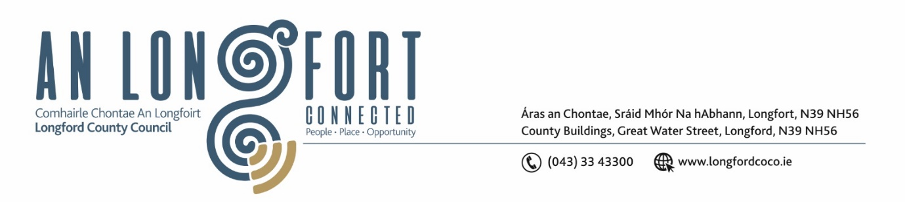

***Please note meeting will be held in the Council Chamber and via Microsoft Teams.***

6 Deireadh Fómhair 2022.

**Chuig: Gach Ball don Chomhairle.**

A Chomhairleoir,

Iarrtar ort bheith i láthair ag Cruinniú Míosuil Chomhairle Chontae Longfoirt a tionólfar i Seomra na Comhairle, Aras an Chontae, Longford agus via MS Teams are an **Chéadaoin 12ú Deireadh Fómhair 2022 ag** **4pm** chun gnó a dhéanamh d’réir an Chláir thíos.

You are requested to attend the Monthly Meeting of Longford County Council to be held in the Council Chamber and **via Microsoft Teams** on **Wednesday 12 October 2022 at 4pm** to transact business, as set out on the Agenda hereunder.

Mise le meas,

*Ann Marie Mc Keon*

**__________________**

**Ann Marie Mc Keon**

**Meetings Administrator.**

**C L Á R**

Prayer before meeting.

**1.** Confirmation of Minutes of Monthly Meeting of Longford County Council held on 14 September 2022– copy enclosed.

**2.** Matters Arising.

**3.** Declaration of Interest by Members.

**4.** To note Management Report – to follow.

**5.** To note adopted Minutes of Corporate Policy Group Meeting held on the

12 July 2022 – enclosed.

**6. Community, Corporate and Enterprise**

1. Electoral Register Modernisation – Elected Members Update.

**7. Planning and Project Delivery**

**(a)** To note Planning Applications received since last meeting of the Council.

**(b)** Residential Zoned Land Tax.

**(c)** Notice of Motions, submitted by Councillors, as listed hereunder:

**Councillor Paraic Brady:**

Can Longford County Council provide the number of houses in our stock that range

from A to G in energy ratings as the cost of heating and electricity has increased and

bills will be more expensive on the lower rated houses.

**Councillor John Browne**

I call on Longford County Council in its capacity as landlords, to develop a programme

of periodic house inspections, of its own houses.

**8. Infrastructure, Housing and Innovation**

**(a)** Consideration of disposal of Properties at numbers 5-7, 12-14, 17, 25-28 Colmcille Terrace, Granard, County Longford (11 units) to Tuath Housing Association in accordance with the terms of Section 183 of the Local Government Act 2001 issued on the 2 September 2022 – as circulated.

**(b)** Consideration of disposal of Property at numbers 8, 9, 11, 20-23 & 29 Colmcille Terrace, Granard, County Longford (8 units), to Tuath Housing Association in accordance with the terms of Section 183 of the Local Government Act 2001 issued on the 2 September 2022 – as circulated.

**(c)** Notice of Motions, submitted by Councillors, as listed hereunder –

**Councillor Paul Ross**

That following the publication of the Social Housing Assessment Regulations in which Longford was left out, that Longford County Council write to the Minister for Housing, Local Government and Heritage Darragh O’Brien to move Longford from Band 3 into Band 2 to raise the basic income threshold from €25,000 to €30,000.

**Councillor Paraic Brady**

I call on Longford County Council to cut all hedges along lands owned by the council

and show good example to farmers and landowners.

**Councillor Uruemu Adejinmi**

I call on Longford County Council to put in a proposal to the Department of Housing for funding for the acquisition of property in Longford to serve as hostel type emergency accommodation for homeless families until they are adequately housed.

**9. Finance and IT**

1. Consideration of Overdraft Accommodation of €15m for year ending 31st December 2023.
2. **DATES FOR BUDGET MEETINGS:**

Granard MD – General Municipal Allocation Meeting – 25 October (pm).

Longford MD – General Municipal Allocation Meeting – 26 October.

Ballymahon MD – General Municipal Allocation Meeting –25 October (am).

Budget 2022 – ‘In Committee’ Meeting –14 November.

Budget 2022 Meeting – 21 November.

**10. General**

**(a)** Notice of Motions, submitted by Councillors, as listed hereunder –

**Councillor Uruemu Adejinmi**

I call on Longford County Council to write to the Garda Commissioner to appoint an immigration officer to be based in Longford Garda Station.

**11. Correspondence**

1. Correspondence dated 14 September 2022 received from the Minister for Housing Re Notice of Motion from Councillor Pat O’Toole on the removal of the population cap on the Affordable Homes aspect of the Housing for All Plan – enclosed.

**12.**  **Training – enclosed.**

**13. Votes of Sympathy.**